Shri Ram college of commerce

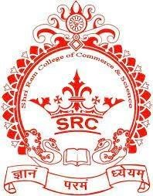
Datta mandir Road, Bhandup (W.)
V sem Internal exam Aug - 2026
Class : TYBsc(CS) Marks : 20
Subject : Software testing & QA Date :
Q1] Solve the following (Any 2) [10 marks]
- Explain the nature of software errors. Why is software testing necessary? Differentiate between Error, Defect (Bug), and Failure with suitable examples.
- Explain the Software Testing Process with a neat diagram. Discuss the activities performed in each phase.
- What is a Test Case? Explain the principles of test case design. Describe any four test case design techniques with examples.
- Explain Test Execution, Test Reporting, and Test Documentation. What documents are prepared during software testing ?
Q2] Solve the following (Any 2) [10 marks]
- What is the Software Development Life Cycle (SDLC)? Explain all SDLC phases with a neat diagram.
- Explain the relationship between SDLC and Software Testing. Discuss the role of testing in each SDLC phase.
- Define Software Quality. Explain the important software quality factors and discuss how they influence software testing.
- Define Quality Assurance (QA), Quality Control (QC), Quality Management (QM), and Software Quality Assurance (SQA). Differentiate between them with suitable examples..

